**-: Practical set – 1 :-**

1. Write a Python program to print “Hello World”.

print("Hello world")

**OUTPUT:**



1. Write a Python program to swap two variables using third variable.

a,b = input("Enter two numbers : ").split()

print("\n* Using third variable *")

print(f"Before swap .. a:{a} b:{b}")

c = b

b = a

a = c

print(f"After swap ..  a:{a}  b:{b}")

**OUTPUT:**

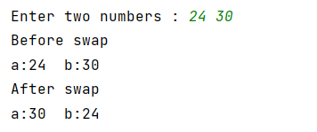

1. Write a Python program to swap two variables without third variable.

a,b = input("Enter two numbers : ").split()

print("\n* Without using third variable *")

print(f"Before swap .. a:{a} b:{b}")

a, b = b, a

print(f"After swap .. a:{a} b:{b}")

**OUTPUT:**

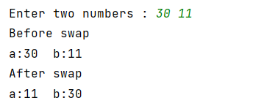

1. Write a Python program to find square root of positive number.

import math

n = int(input("\nEnter the number : "))

print(f"Sqaure root : {math.sqrt(n)}")

**OUTPUT:**

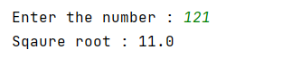

1. Write a Python program to find area of a rectangle and circle.

import math

len = float(input("Enter the length of Rectangle (in cm) : "))

wid = float(input("Enter the width of Rectangle (in cm) : "))

rad = float(input("Enter the radius of Circle (in cm) : "))

print(f"Area of Rectangle : {len*wid} cm square")

print(f"Area of Circle : {math.pi*rad*rad : .4f} cm square")

**OUTPUT:**



1. Write a Python program to find sum of *n* natural numbers without loop.

n = int(input("Enter the number : "))

print(f"Sum : {(n*(n+1))/2}")

**OUTPUT:**

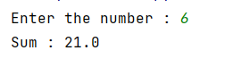

1. Check various arithmetic operators of Python.

num1, num2 = float(input("Enter two numbers : ")).split()

print(f"Sum : {num1 + num2}")

print(f"Subtraction : {num1 - num2}")

print(f"Multiplication : {num1 * num2}")

print(f"Division : {num1 / num2}")

print(f"Modulo : {num1 % num2}")

print(f"Floor division : {num1 // num2}")

print(f"Power : {num1 ** num2}")

**OUTPUT :**

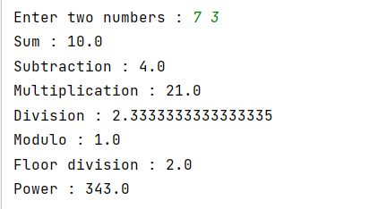

1. Write a Python program to check output of modulo operator.

print(f"Modulo : {15%2}")

**OUTPUT:**

